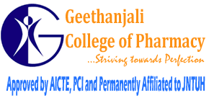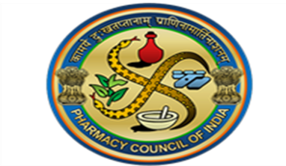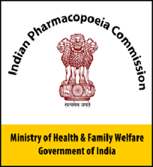
Geethanjali College of Pharmacy Accredited by NAAC A+ Grade, NBA (B.Pharmacy) Approved by AICTE, PCI New Delhi, Permanently Affiliated to JNTUH, HI/BI of MSME, ISO 9001:2015 Certified, Recognized by DSIR-SIRO, Under Section 2(f), 12(B) of UGC Act 1956, AMC of PvPI , Cheeryal (V), Keesara (M), Medchal Dist., Telangana State- 501301.
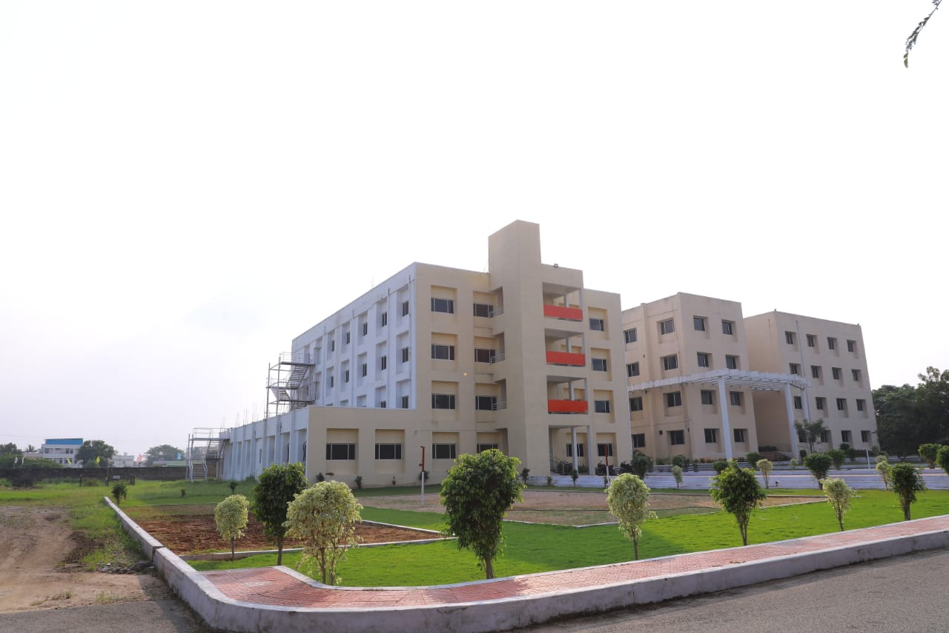
CONSOLIDATED REPORT ON
NATIONAL PHARMACOVIGILANCE WEEK

17th - 23rd September, 2024

THEME
“BUILDING ADR REPORT CULTURE FOR PATIENT SAFETY”

ORGANIZED BY
Department of Pharmacology

Sponsored by
Teja Educational Society, Hyderabad
CONTENTS

1.0 | Introduction
2.0 | Objective
3.0 | Programme Schedule
4.0 | Addressing the event
5.0 | List of various Events
6.0 | Prize Distribution Ceremony
7.0 | Valedictory Ceremony
8.0 | List of staff, volunteers, paticipants

- INTRODUCTION

Geethanjali College of Pharmacy, Cheeryal, Hyderabad was established in the year 2007 and has organized National Pharmacovigilance Week from 17th - 23rd September, 2023 with the theme “BUILDING ADR REPORT CULTURE FOR PATIENT SAFETY” organized by the Department of Pharmacology, Sponsored by Teja Educational Society, Hyderabad.
Considering the need, the PvPI has established 567 ADR monitoring centres across the country with the main mission to safeguard health of Indian population, it will serve as a platform for knowledge enrichment to the various stakeholders in the field of safety of medical products for ultimate benefit of patients.

Various materials have been used to propagate the theme and the message to celebrate the national pharmacovigilance week.

PVPI 2024 BROCHURE

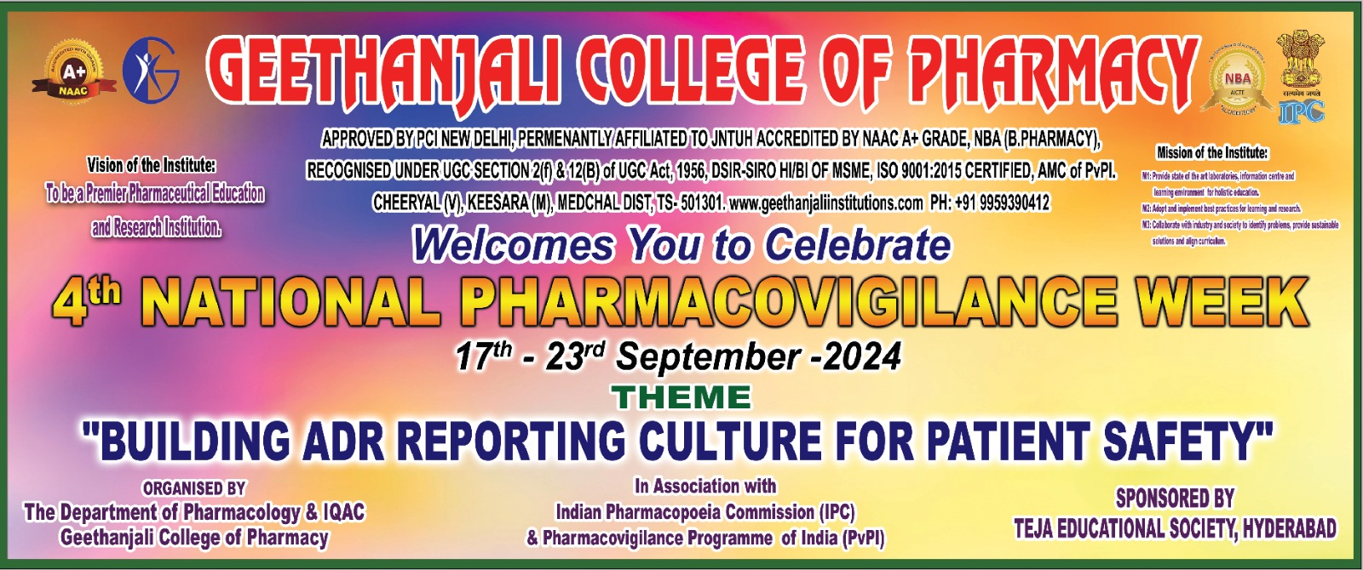
Figure 1: PvPI 2024 Brochure

PVPI Circular
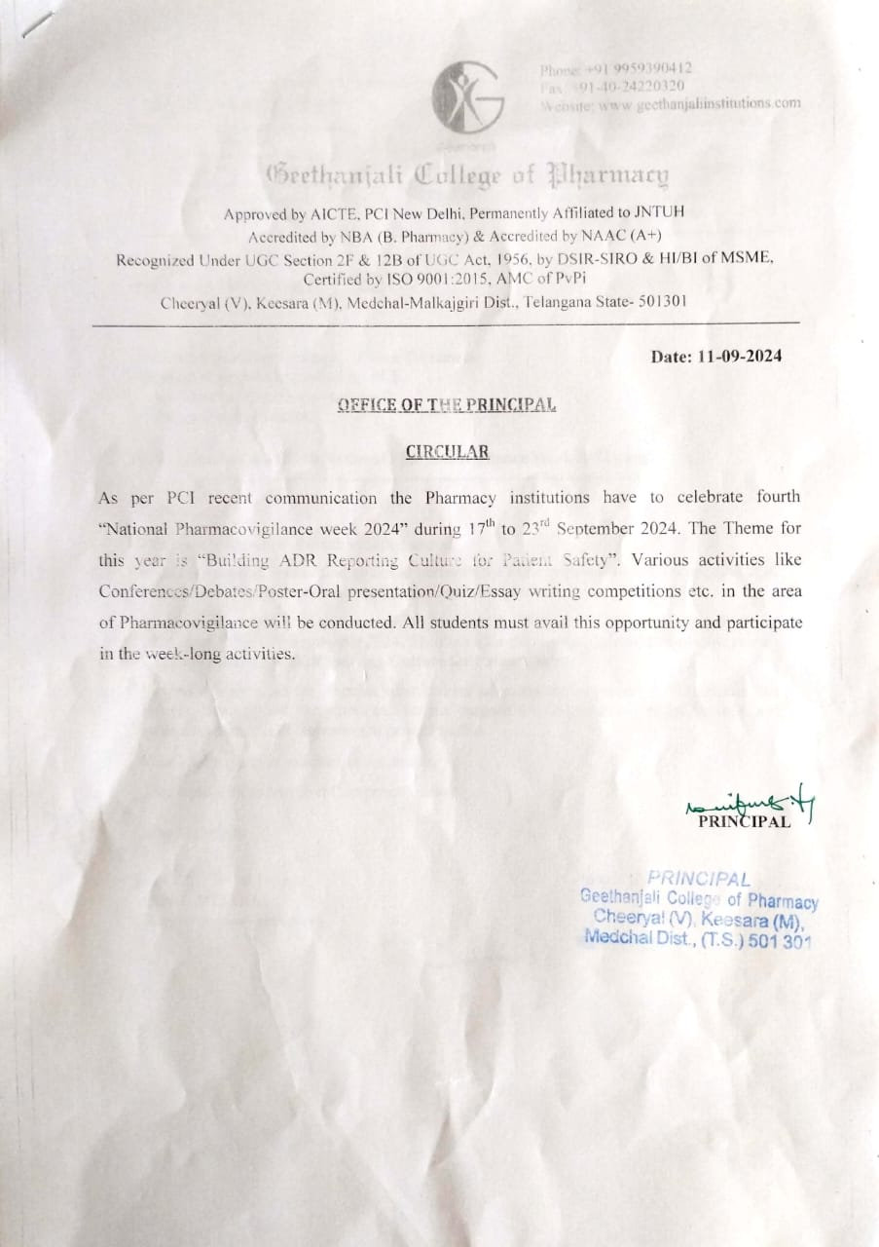
Figure 2: PvPI 2024 Circular

2.0 OBJECTIVE
Indian Pharmacopoeia Commission (IPC), National Coordination Centre (NCC) - Pharmacovigilance Programme of India (PvPI) celebrates the National Pharmacovigilance Week from 17th - 23rd September, 2024 with the main objective to create awareness among the community about the safety of drugs, patient safety in special population, importance of ADR reporting, importance about the role of frontline health professionals in monitoring Pharmacovigilance activities, inspire the students, community for the betterment and the responsible use of medicines.
The Pharmacovigilance Week Celebrations Can be an ideal platform to honour fellow healthcare professionals who are an integral part of the healthcare system and drug safety.
2024 SCHEDULE

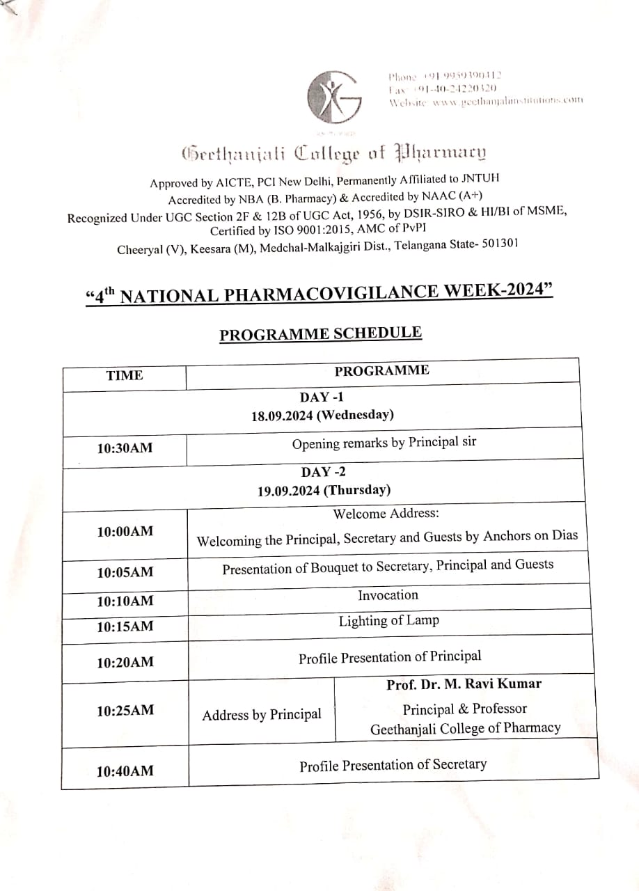
3.0 PROGRAMME SCHEDULE

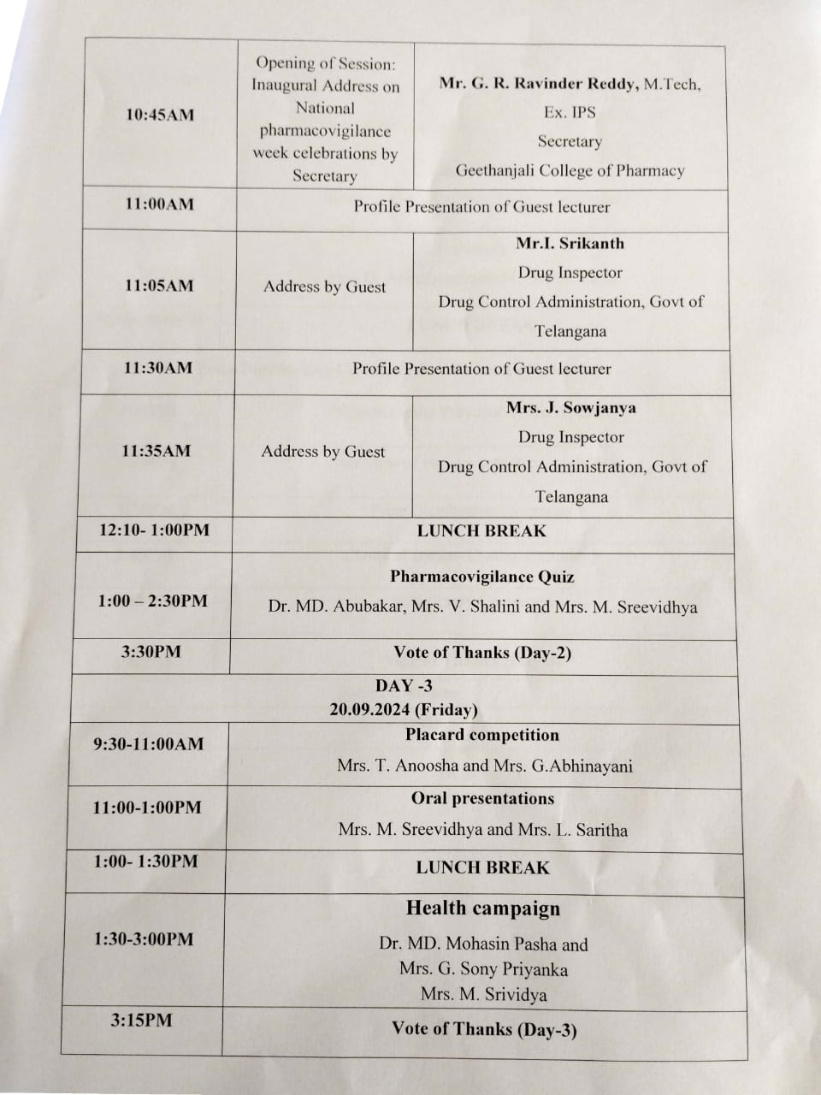
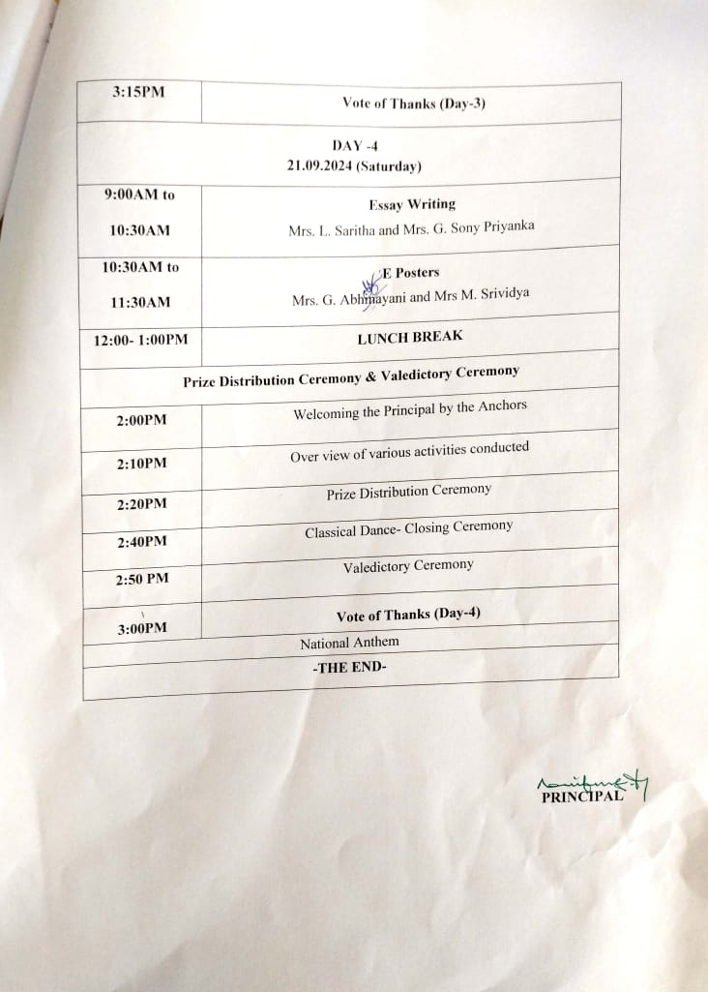
Figure 3 : PvPI 2024 schedule
4.0 ADDRESSING THE EVENT
Principal welcomed the students, participants and faculty to celebration of National Pharmacovigilance Week, explained the role of Pharmacists in pharmacovigilance activities, ADR reporting importance and measures to take for patient drug safety .
On 18.09.2024
- The opening remarks of pharmacovigilance week celebrations was given by Prof M. Ravi Kumar Principal, Geethanjali College of Pharmacy.
- Sir reminded the importance of reporting ADR to monitoring centres and the role of pharmacist in bringing awareness among the public regarding ADR reporting.

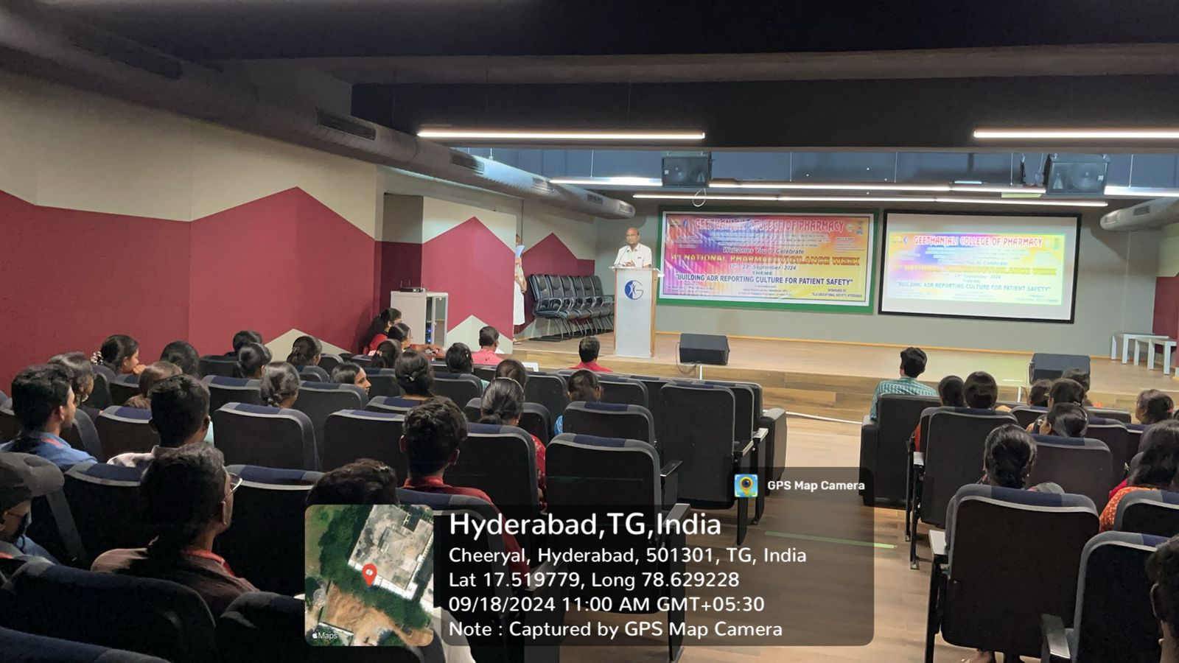
Figure 4: Welcome Speech

On 19.09.2024
- The opening of pharmacy week celebrations was done by Mr. G. R. Ravinder Reddy M.Tech, Ex. IPS Secretary, Geethanjali College of Pharmacy.
- Inaugural Address was done by Prof M. Ravi Kumar Principal, Geethanjali College of Pharmacy
- The event started with invocation of almighty, lightning of lamp by our esteemed chief guests Mr. I. Srikanth Ms Pharma, Drug Inspector, Drug control Administration, Govt of Telangana and Mrs J. Sowjanya, Drug Inspector, Drug control Administration, Govt of Telangana.
- They gave their valauable insights stating the importance of ADRs reporting and the role of community pharmacy in bringing awareness among the public regarding how to report ADRs in the monitoring centres.
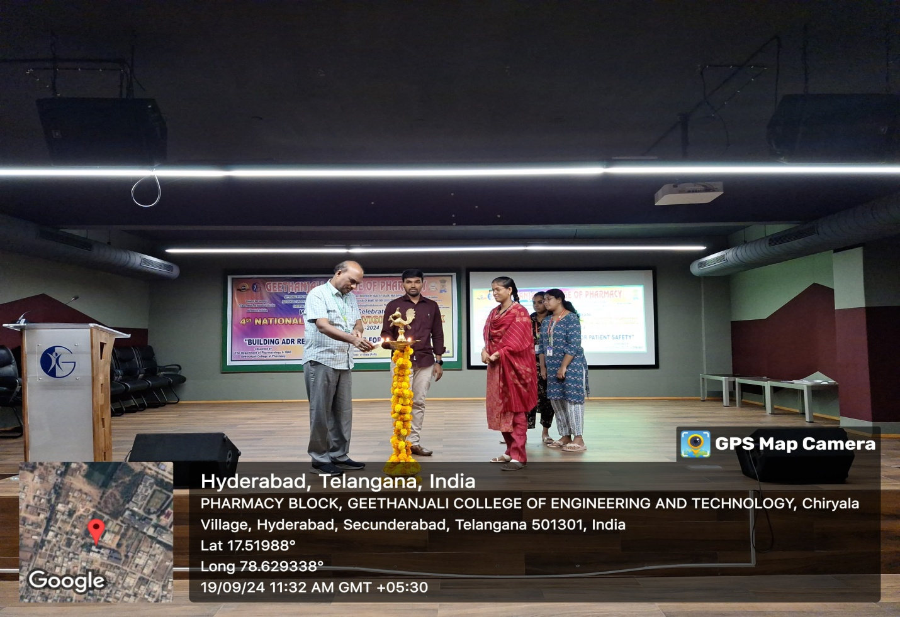
Figure 5: Lightning Of Lamp By Prof M. Ravi Kumar, Principal, Mr. I. Srikanth Drug Inspector & Mrs J. Sowjanya Drug Inspector.

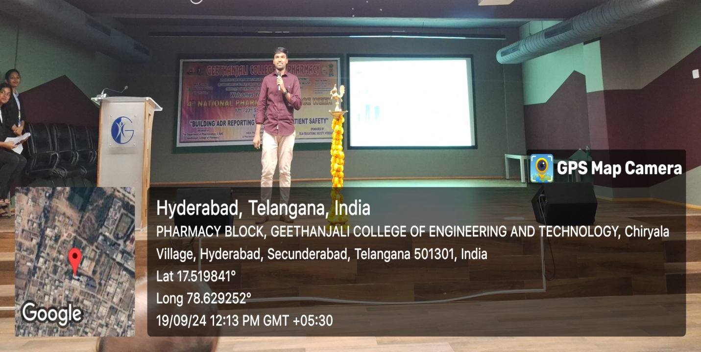
Figure 6 : Mr. I. Srikanth Drug Inspector, sharing his valauable insights on the occasion of NPW 2024 celebrations.

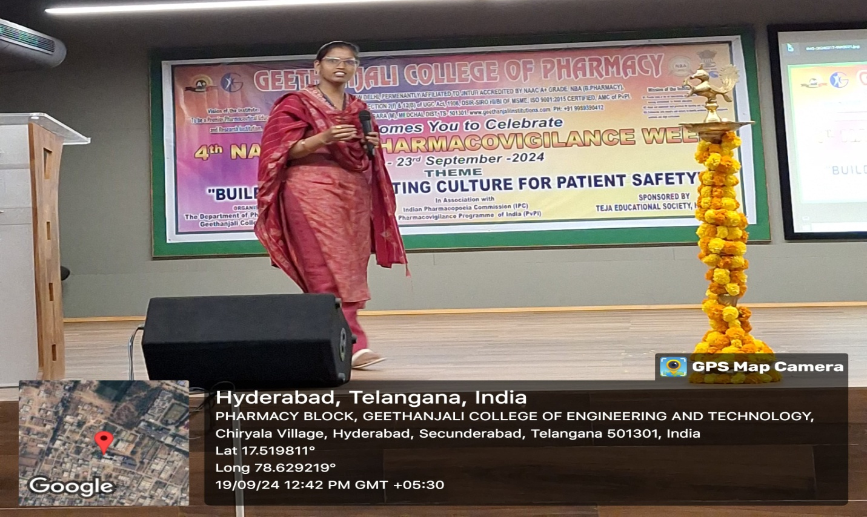
Figure 7 : Mrs J. Sowjanya Drug Inspector, sharing her valauable insights on the occasion of NPW 2024 celebrations.
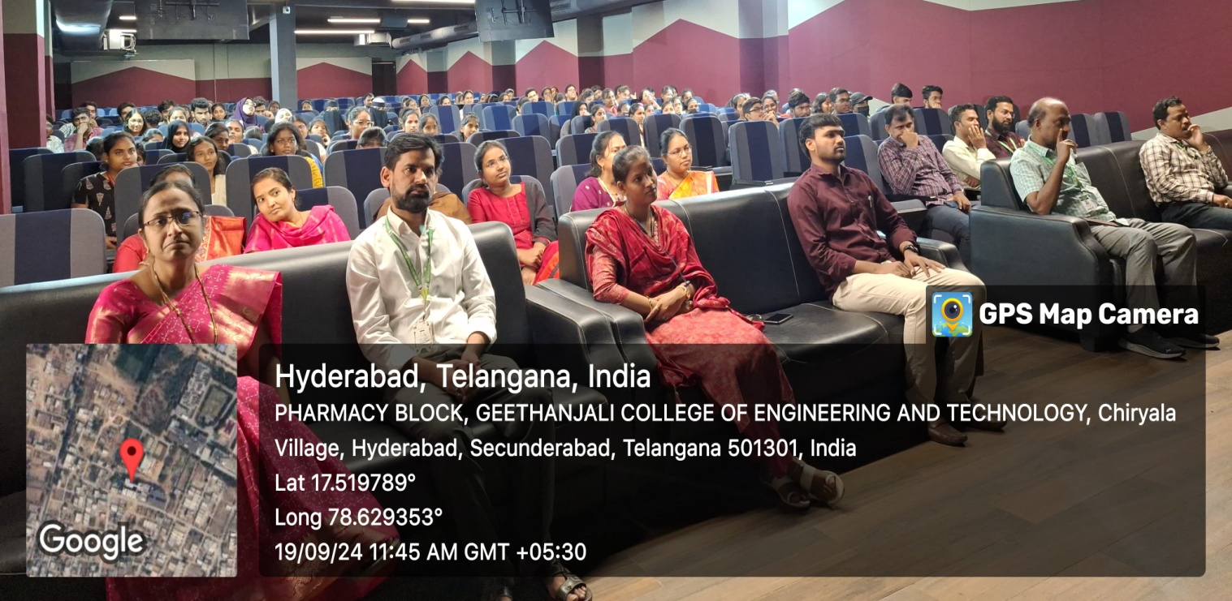
Figure 9 : Participants

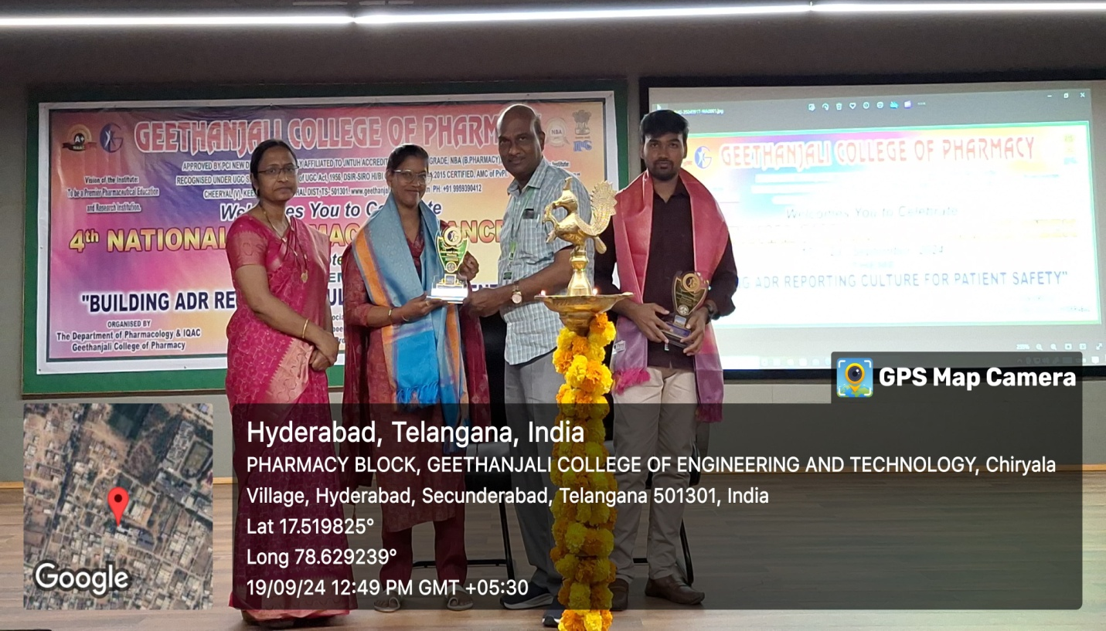
Figure 10 : Felicitation of chief guests.

6.0 LIST OF VARIOUS EVENTS CONDUCTED
PHARMACOVIGILANCE QUIZ
The event Quiz was successfully conducted on 19/09/2024 under the coordination of Dr. MD. Abubakar, Mrs. V. Shalini and Mrs. M. Sreevidhya.
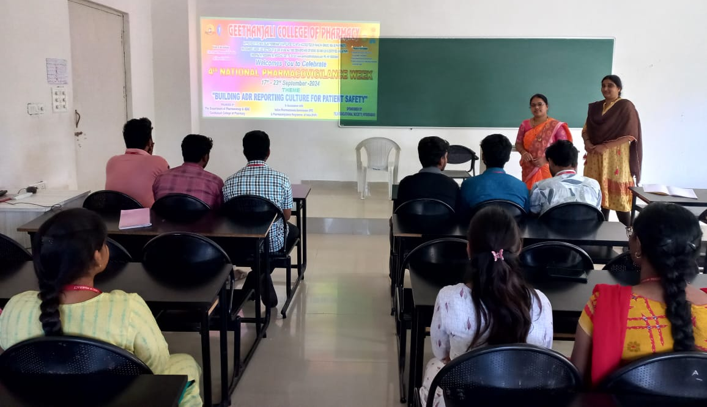
Figure 11 : Conducting Quiz Competition

ORAL PRESENTATIONS
The oral presentations was successfully conducted on 20/092024 under the coordination of Mrs. M. Sreevidhya and Mrs. L. Saritha.
ORAL PRESENTATION COMPETITION GUIDELINES
- Each participant has to make the PPT, related to “BUILDING ADR REPORT CULTURE FOR PATIENT SAFETY”.
- Each participant should give oral presentation of 8 minutes and after that 2 minutes for regarding question are asked.
- Document should comprise of Code, participant name, HT No, Year and college details.
- The decision of the Judges/Evaluators will be final and cannot be challenged.
PRESENTATION EVALUATION FORM
Name of Presenter: Code: Date:
Diagnosis: Evaluated by:

S.NO | COMPETENCY | EVALUATION/GRADE
1 | Organization & Verbal Presentation | /3
2 | Case collection | /3
3 | SOAP format | /3
4 | Standard Pharmacotherapeutic Plan Development | /3
5 | Knowledge about Topic | /3
6 | Drug Interactions &Interventions | /2
7 | Patient counselling | /3
8 | Bibliography | /1
9 | Viva-voce | /2
10 | Recent advancement in the therapy | /7

NOTE: Evaluate on the Scale of 5 to 30
Poor | Fair | Below Average | Average | Above Average | Excellent
5 | 10 | 15 | 20 | 25 | 30

GRADE/POINTS: SIGNATURE OF EVALUATOR

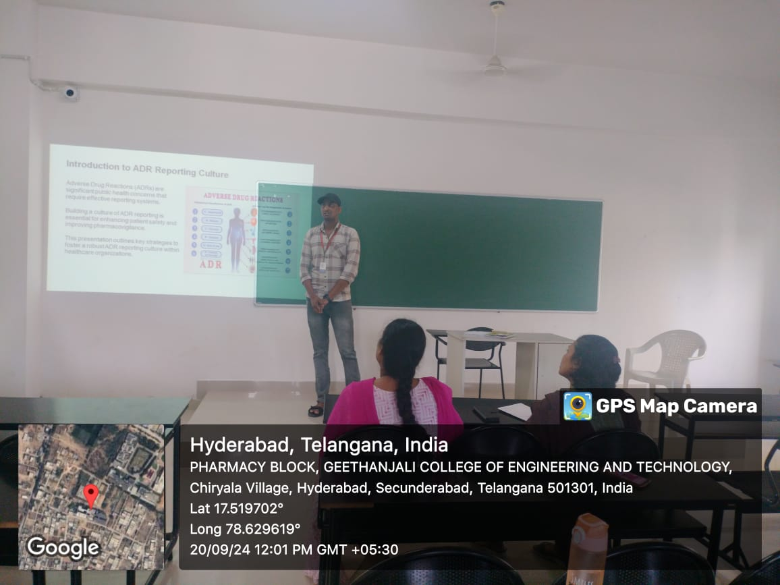
Figure 12 : Conducting Oral Presentations Competition
HEALTH CAMPAIGN
Students along with staff conducted a Health campaign in cheeryal village creating the awareness of reporting ADR by Patients on 20/9/24 under the coordination of Dr. MD. Mohasin Pasha Mrs G. Sony Priyanka & Mrs M. Srividya.
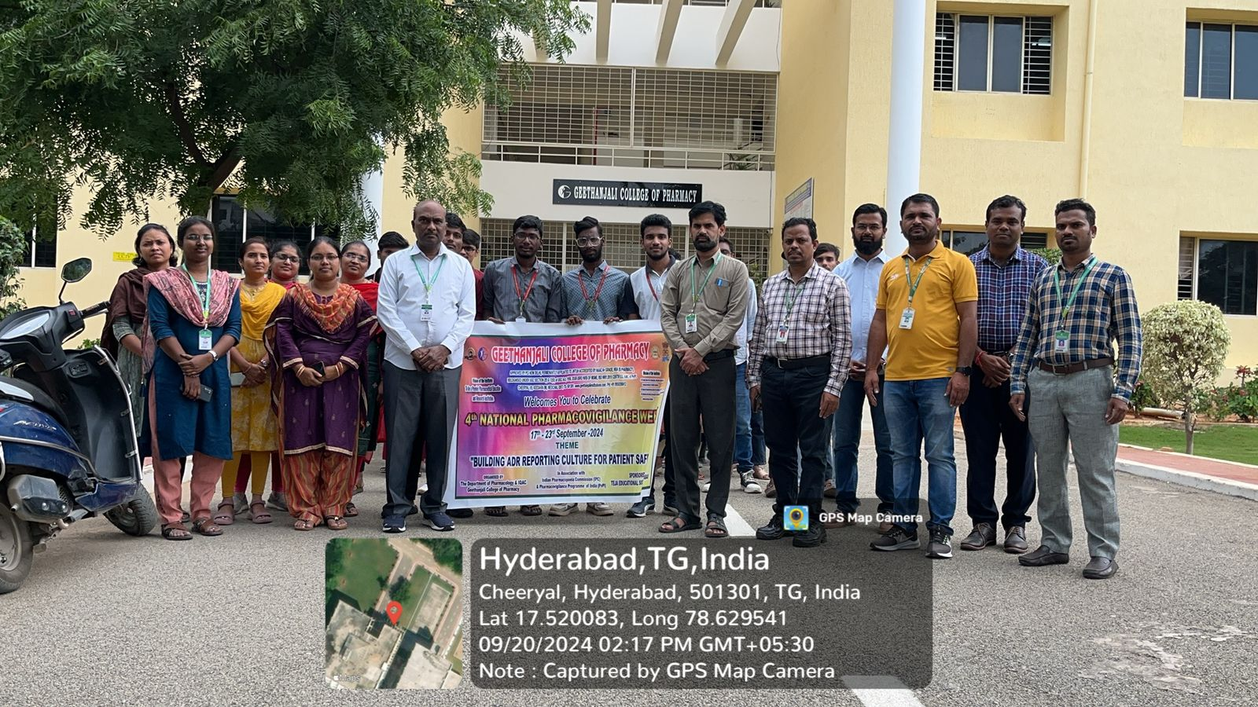
Figure 13 : Health Compaign.
ESSAY WRITING
The event Essay writing competition was successfully conducted on 21/09/2024 under the coordination of Mrs. L. Saritha and Mrs. G. Sony Priyanka .
Evaluation of Essay Writing

S No | Parameter | Score
1 | Does the Essay make clear beginning related to Theme | /5
2 | Does the Essay make clear Introduction | /5
3 | Does the Essay make clear Body | /5
4 | Does the Essay make clear Conclusion | /5
5 | Is the Essay easy to read, organized in straightforward way, and free from grammar, spelling, and punctuation errors | /5

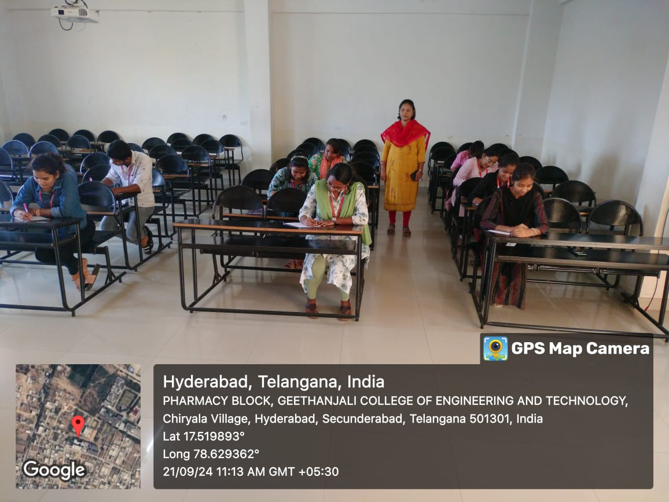
Figure 14 : Conducting essay writing competition

7.0 PRIZE DISTRIBUTION CEREMONY
On 21.09.2024
Prize Distribution Ceremony & Valedictory Ceremony
- Various competitions were organized as a part of National Pharmacovigilance Week like
Essay writing competition, Oral presentations, Pharmacovigilance quiz. Total 86 students participated in the event.
The winners & Runners are awarded with trophies and certificates to mark their achievement.
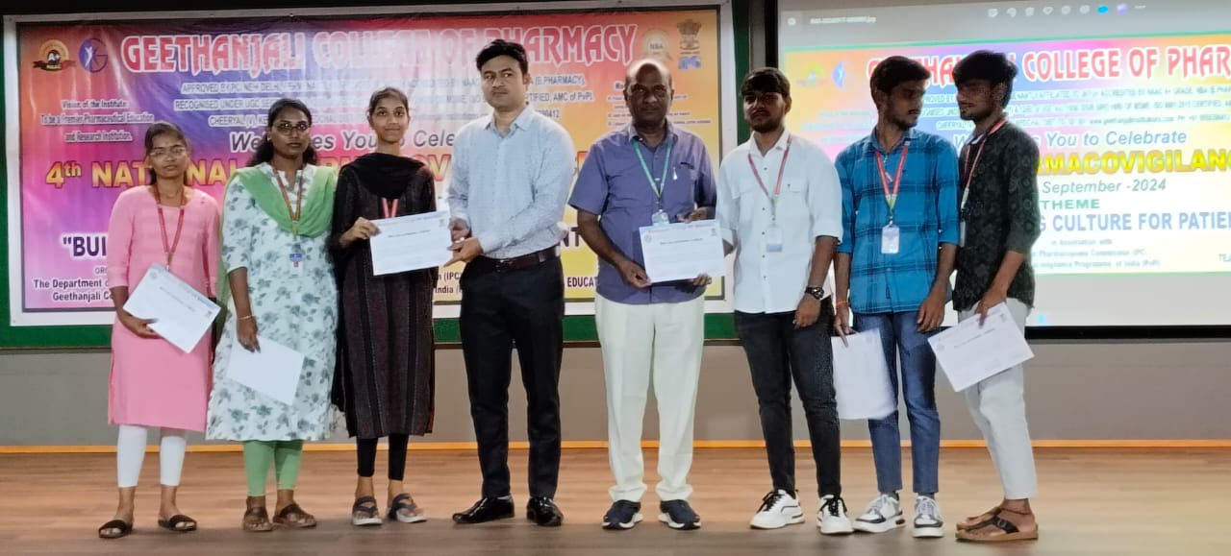
Figure 15: Faculty With Students Who won The Prizes in Various Activities.
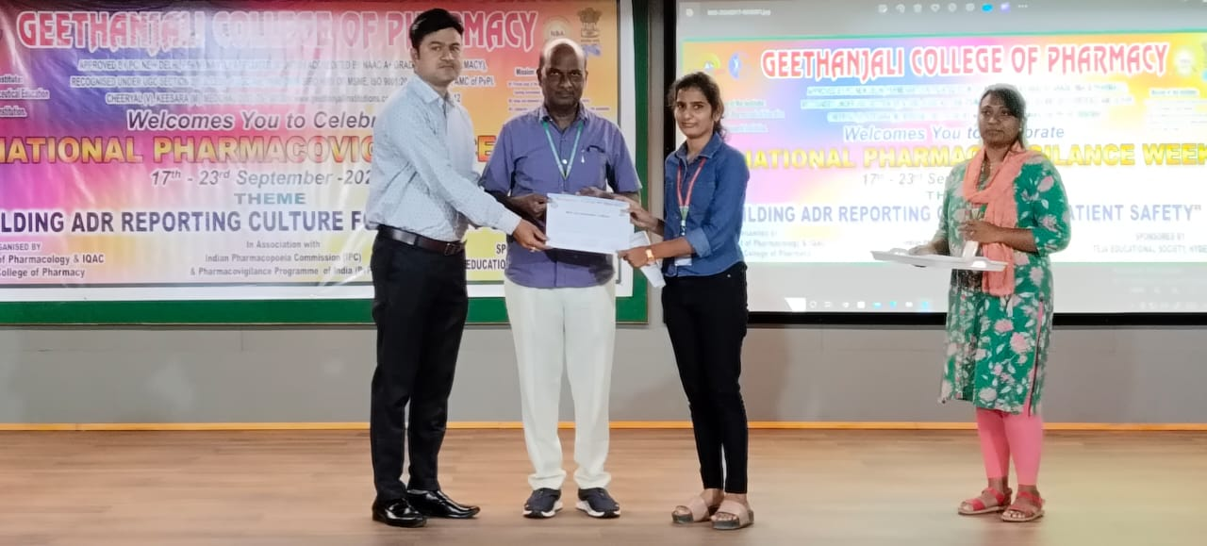
Figure 16: Principal Sir Distributing Prizes To Winners
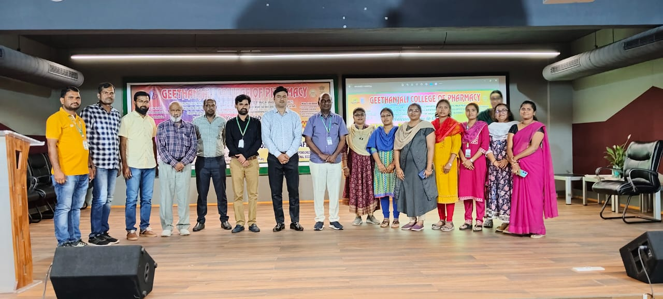
Figure 17: Faculty who organized PVPI 2024.

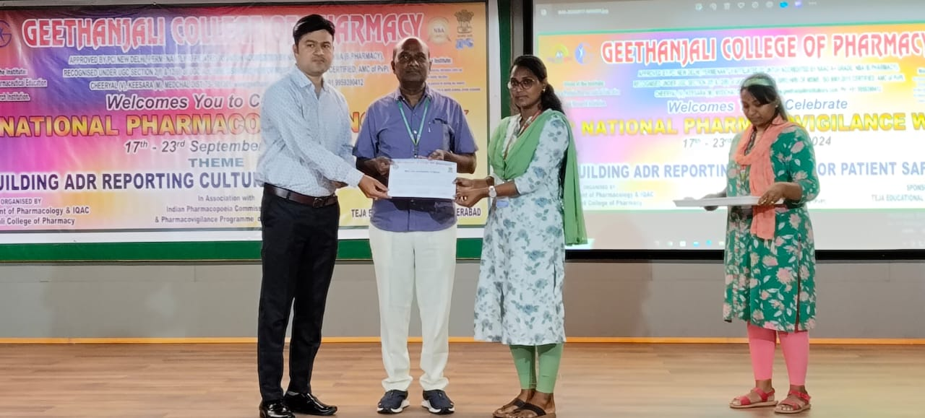
Figure 18: Principal Sir Distributing Prizes To Winners

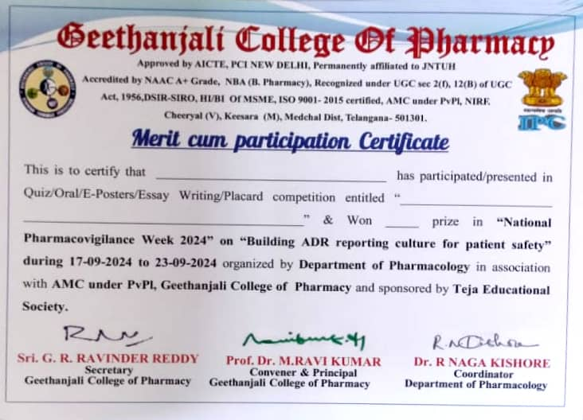
Figure 19: Sample Certificate

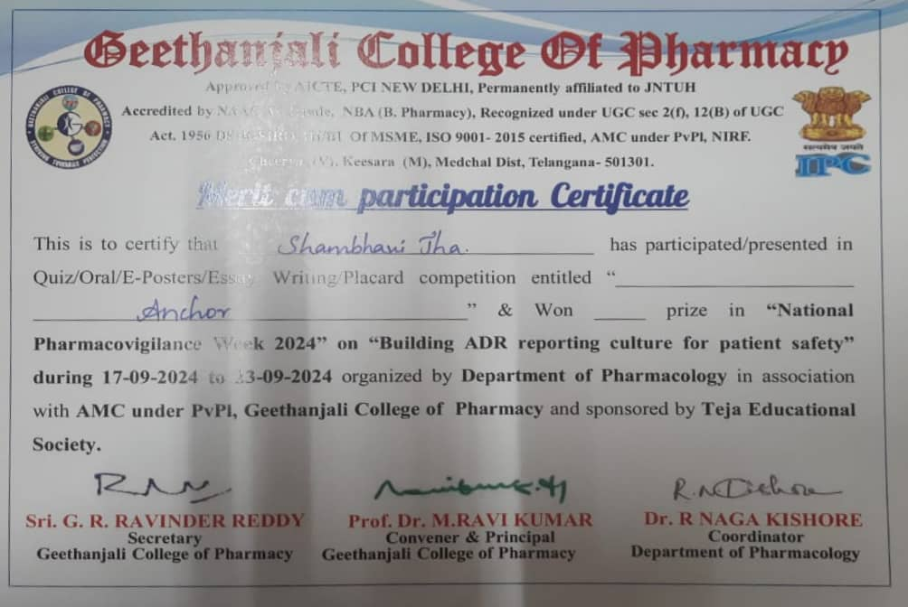
Figure 20: Student Certificate
LIST OF FACULTY WHO PARTICIPATED IN PVPI-2023
S.NO | NAME OF THE FACULTY
1 | Dr M Ravikumar
2 | Dr. M. Srinivas
3 | Dr. R. Siva Kumar
4 | Dr. B.B. Mohapatra
5 | Dr. N. Anjaneyulu
6 | Dr. R. Naga Kishore
7 | DR. P. Neeraja
8 | DR. J. Sunil
9 | DR. Y. SHIVA KUMAR
10 | M. Satish Kumar
11 | Ch. Sumalatha
12 | Abubakar Md
13 | V. Shalini
14 | B. Sandhya
15 | R. Umadevi
16 | P. Shankaraiah
17 | M. Mohasin Pasha
18 | T. Anoosha
19 | J. Naveen
20 | B. Anitha
21 | K. Laxmi Rajitha
22 | B. Santhosh Kumar
23 | G. Laxmi Prasanna
24 | P.Jyothi
25 | K. Sai Prabha
26 | Kishor kumar Reddy.K
27 | N. Swetha
28 | K. Mounika
29 | S.D. Shalini
30 | S. Kiranmai
31 | A. Abhinayani
32 | B. Swathi
33 | K. Prashanth Kumar
34 | L.Devakamma
35 | S.Naga Chandrika
36 | A. Madhavi
37 | D. ASHLESHA
38 | S. Rani
39 | B. Supraja
40 | U. Rishika
41 | B. Mamatha
42 | Dr.Abdul Nazer Ali
43 | K. Divya Jyothi
44 | M. Sreevidhya
45 | S. VIJAY KUMAR
46 | L.SARITHA
47 | G.Sony Priyanka
48 | I.Neelam
49 | Manthena Srividya
50 | Ch. Chaithanya
51 | G. Sandhya Rani
52 | Dr. K.Pallavi
 | S & H (DEPT)
51 | A. SRINIVAS
52 | K SWAPNA
53 | A.Veeranna

8.0 List Of Students Participated In Various Activities
“NATIONAL PHARMACOVIGILANCE WEEK 2024”
QUIZ PARTCIPANTS AND WINNERS (19/09/2024 )
 | TEAM 1- WINNERS
1 | RAGIRI SURYA KANTH REDDY | 21Z51T0027
2 | MERUGU AJAY | 21Z51T0018
3 | P SAI TEJA | 21Z51T0024
 | TEAM 2- RUNNERS
4. | MUSOJU SOWMYA | 21Z51T0019
5. | BANDIRALA BHAVANA | 21Z51T0003
6. | ADLA BHANUSHOBHITHA | 21Z51T0001
 | TEAM 3
7. | RATHLAVATH DEVENDAR | 21Z51T0028
8. | PALLAPU PRAVEEN KUMAR | 21Z51T0020
9. | VAKITI DARSHAN KUMAR | 21Z51T0031
 | TEAM 4
10. | ARIGE TEJASRI | 21Z51T0002
11. | VYDYULA NAVYA SRI | 21Z51T0032
12. | GUJJA VAISHNAVI | 21Z51T0012
ORAL PRESENTATIONS-PARTCIPANTS AND WINNERS (21-09-2023)
 | WINNER- 1ST PRIZE
13 | YENIGANTI ADARSH KUMAR | 21Z51R00A3
 | RUNNERS- II PRIZE
14 | JAGATHA LASYA VAIDEHI VANI | 21Z51R0019
 | RUNNERS- III PRIZE
15 | JETTURU SWETHA | 21Z51T0014
ESSAY WRITING -PARTCIPANTS AND WINNERS (21/09/2024)
 | WINNER 1ST PRIZE
16 | JETTURU SWETHA | 21Z51T0014
 | RUNNERS I1ST PRIZE
17 | VYDYULA NAVYA SRI | 21Z51T0032
 | RUNNERS 1II ST PRIZE
18 | BOOMPAGU CHITRA | 21Z51T0005
 | PARTICIPANTS
19 | BANDIRALA BHAVANA | 21Z51T0003
20. | RAGIRI SURYA KANTH REDDY | 21Z51T0027
21. | ARIGE TEJASRI | 21Z51T0002

